**Media data**

~~Cleaning:~~

* ~~Only numbers 2019 and 2020~~
* ~~To do:~~
  + ~~Check data formats~~
  + ~~Complete cleaning 'Number of rescued people when crossing borders & Number of arrived people through boarders~~
  + ~~Complete cleaning 'Number of people deported through borders'~~

Thoughts:

* Can we find increase in specific events in media and interview data on specific dates (increase in x is correlated with more economic need)
* For purpose of this report, only looked at country → could be good to look at city to know where help should be placed
* How was the media data extracted?
* Cannot use this data to look into COVID cases and healed as not reported
* Do the languages exclude minority groups from knowing what is happening in the media?

Issues:

* Same info in different articles
* Needs to be validated somehow?

Visualisations:

* Event type based on **city,** source type, language
* What event types do different source countries report?
* Is there correlation between numbers and event types
* Event type per date period per country --. Maybe multiple pie charts - one for each country???
* Event type with precision mapping (country or city??)

**Interview data**

* Count of no. of interviewees
* ~~Count of split in migrants~~ → added
* ~~Count of split in source person~~ → added
* Access to healthcare & fear of covid based on precision migrant
* Access to healthcare & fear of covid based on precision source
* Access to healthcare & fear of covid based on country → better visualisation
* ~~Type of help received per precision migrant, precision source country~~
* ~~NGO per country~~

Questions: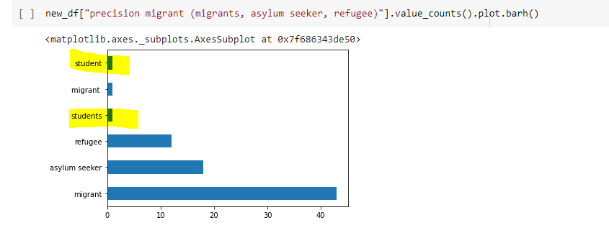

* Were responses cleaned - 'precision migrant (migrants, asylum seeker, refugee)'

2. Shall we just add the total no. in each group otherwise this may be misleading? --. Absolute plot exists

* 